**“WOKIEE”**

##### **A SUMMER INTERNSHIP REPORT**

***Submitted by***

# **KAKADIYA SMIT VIKRAMBHAI**

**[190430116052]**

***In partial fulfilment for the award of the degree of***

# **BACHELOR OF ENGINEERING**

# ***in***

##### **Information Technology**

##### **Shantilal Shah Engineering College, Bhavnagar**

 

# **Gujarat Technological University, Ahmedabad**

**July, 2022**

 

**Shantilal Shah Engineering College**

Sidsar campus, Bhavnagar.

**CERTIFICATE**

This is to certify that the Summer Internship report submitted along with the project entitled “**Wokiee”** has been carried out by **Kakadiya Smit Vikrambhai (Enrollment No. 190430116052)** under my guidance in partial fulfilment for the degree of Bachelor of Engineering in Information Technology, 7th Semester of Gujarat Technological University, Ahmadabad during the academic year 2022-23.

Prof. S. J. Agravat Prof. Milind Shah

Internal Guide Head of the Department (I.T.)

 

**Shantilal Shah Engineering College**

**Sidsar Campus, Bhavnagar**

**DECLARATION**

We hereby declare that the Summer Internship report submitted along with the Project entitled **“Wokiee”** submitted in partial fulfilment for the degree of Bachelor of Engineering in Information Technology to Gujarat Technological University, Ahmedabad, is a bonafide record of original project work carried out by me at Shantilal Shah Engineering College - Bhavnagar under the supervision of Prof. Shardul J. Agravat and that no part of this report has been directly copied from any students’ reports or taken from any other source, without providing due reference.

Name of Student Sign of Student

Kakadiya Smit Vikrambhai

________________________ ___________________

## Acknowledgement

I am heartily thankful to all faculty members of the department of information technology from SSEC-BHAVNAGAR, for this Internship Project.

It is my pleasure to take this opportunity to thank all people who helped us directly or

indirectly to prefer in this Internship would I have been impossible without their guidance. deeply grateful to our supervisor, Prof. Sardul Agravat, for his guidance, patience and support. They were always available for us to give guidance about the Internship.

#### ABSTRACT

##### Wokiee is a website for online retailers. The main objective of this website is to make it interactive and its ease of use. It would make searching, viewing and selection of a product easier. The search engine provides an easy and convenient way to search for products where a user can Search for a product interactively and the search engine would refine the products available based on the user's input. The user can then view the complete specification of each product. They can also view the product reviews and also write their own reviews. The website also provides a drag and drop feature so that a user can add a product to the shopping cart by dragging the item in to the shopping cart. The main emphasis lies in providing a user-friendly search engine for effectively showing the desired results and its drag and drop behavior.

## List of Figures

Fig. 3.1 Entity Relationship Diagram…………………………………….………….……...6

Fig. 3.2 Context Level Data Flow Diagram……………………………….….…....................7

Fig. 3.3 1-Level Data Flow Diagram……………………………………….……………….7

Fig. 3.4 2-Level Data Flow Diagram……………………………………….……………......8

Fig. 3.5 2-Level Data Flow Diagram……………………………………….……………….9

Fig. 3.6 Use Case Diagram………………………………………………….…...................10

Fig. 4.1 Home Page Header………………………………………………….…………….11

Fig. 4.2 Home Page…………………………………………………………………………11

Fig. 4.3 Home Page…………………………………………………………………………12

Fig. 4.4 Home Page Exclusive Product…………………………………………………….12

Fig. 4.5 Home Page Footer………………………………………………………………….13

Fig. 4.6 Products Page………………………………………………………………………13

Fig. 4.7 Products Page………………………………………………………………………14

Fig. 4.8 Products Details Page………………………………………………………………14

Fig. 4.9 Products Details Page………………………………………………………………15

Fig. 4.10 Account Page………………………………………………………………...…….15

Fig. 4.11 Account Page………………………………………………………………………16

Fig. 4.12 Cart Page………………………………………………………………………….16

#### Table of Contents

#### Acknowledgements

#### ABSTRACT

#### List of Figures

#### Table of Contents

#### Chapter 1 Introduction……………………………………………….……………………...1

#### 1.1 Goal ……………….…………………………...………………...…….….…...………...1

#### 1.2 Need……………………………………….…...……………………….………...……...1

#### 1.3 Scop………………………………………….…………….…………...…………...…...2

#### Chapter 2 System Analysis………………………………………….……….……………....3

#### 2.1 Information Gathering…………………………………………….……....……….…….3

#### 2.2 System Feasibility…………………………………………………...…….……..............4

#### 2.2.1 Economic Feasibility……………………………...…………………………….4

#### 2.2.2 Technical Feasibility…………………………...……………………………….4

#### 2.2.3 Behavioral Feasibility……………………………………………...…….……...4

#### 2.3 Modules of System………………………………………………...…………………….4

#### 2.3.1 Shop Products Module……………………………………….…………………4

#### 2.3.2 Product Description Module…………………………….……………………....5

#### 2.3.3 Shopping Cart Module……………………………………….………………….5

#### 2.4 Selection of Hardware and Software………………………….………………………….5

#### 2.4.1 Hardware Specification……………………………………………………........5

#### 2.4.2 Software Specification………………………………………………………….5

#### Chapter 3 System Design………………………………………………………………….…6

#### 3.1 ER Diagram……………………….……………………………………………….…….6

#### 3.2 Data Flow Diagram……………………….………………………………………….….7

#### 3.3 Use Case Diagram…………………………………........................................................10

#### Chapter 4 Implementation…………………………………………………………...…….11

#### 4.1 User Interface……………………………………………………………………...……11

#### Chapter 5 Conclusions………………...……………………………………………………17

#### 5.1 Limitations…………………………………………………………………….….…….17

#### 5.2 Scope for Future Work……………………...………………………………….….……17

#### REFERENCES

## Introduction

### Goal

Shopping has long been considered a recreational activity by many. Wokiee is no exception. The goal of this website is to develop a web-based interface for online retailers. The system would be easy to use and hence make the shopping experience pleasant for the users. The goal of this website is

* + - To develop an easy-to-use web-based interface where users can search for products, view a complete description of the products and order the products.
    - A search engine that provides an easy and convenient way to search for products specific to their needs. The search engine would list a set of products based on the search term and the user can further filter the list based on various parameters.
    - An AJAX enabled website with the latest AJAX controls giving attractive and interactive look to the web pages and prevents the annoying post backs.
    - Drag and Drop feature which would allow the users to add a product to or remove a product from the shopping cart by dragging the product in to the shopping cart or out of the shopping cart.
    - A user can view the complete specification of the product along with various images and also view the customer reviews of the product. They can also write their own reviews.

### Need

There are large numbers of commercial Online Shopping web application offering large number of products tailored to meet the shopping interests of large number of customers. These online marketplaces have thousands of products listed under various categories.

Problem:

* + - The basic problems with the existing systems are the non-interactive environment they provide to the users.
    - The use of traditional user interfaces which make continuous post backs to the server; each post back makes a call to the server, gets the response and then refreshes the entire web form to display the result. This scenario adds an extra trade off causing a delay in displaying the results
    - A search engine that would display the results without allowing the users to further filter the results based on various parameters.
    - Use of traditional and non-user-friendly interfaces that are hard to use

**Solution:**

* + - The motive of this Online Shopping Website is to allow the user to play with the search tool and create different combinatorial search criterion to perform exhaustive search.
    - Making the application AJAX enabled gets rid of these unnecessary delays letting the user to perform exhaustive search. The users of this application can easily feel the difference between the Ajax empowered user interfaces vs. traditional user interfaces.
    - Provide Interactive interface through which a user can interact with different areas of application easily.
    - A search engine that provides an easy and convenient way to search for products specific to their needs. The search engine would list a set of products based on the search term and the user can further filter the list based on various parameters.
    - Provide Drag and Drop feature thereby allowing the user to add products to or remove products from the shopping cart by dragging the products in to or out of the shopping cart.

### Scope

* + - The current system can be extended to allow the users to create accounts and save products in to wish list.
    - The users could subscribe for price alerts which would enable them to receive messages when price for products fall below a particular level.
    - The current system is confined only to the shopping cart process. It can be extended to have a easy to use check out process.
    - Users can have multiple shipping and billing information saved. During checkout they can use the drag and drop feature to select shipping and billing information.

## System Analysis

### Information Gathering

As the goal of the website is ease of use and to provide an interactive interface, extensive research has been done to gain an insight into the needs and behaviors of various users. The working of the website is made convenient and easy to use for the end user.

Users can be classified into two types based on their knowledge of the products that suit their needs. They can be classified as users who know about the product that would satisfy their needs and users who have to figure out the product that would satisfy their needs. Users who know about the product should be able to find the product easily with the click of a button. Such users can search for the product by using the product name as the search term. Users who have to figure out the product that would satisfy their needs could use a search term to find a list of products and then should be able to filter the results based on various parameters like product type, manufacturer, price range, platform supported etc.

The users should be able to view the complete specification of the product and various images at different Zoom levels. The user should be able to read the customer reviews for the product and the ratings provided. They should be able to write their own reviews. They should be able to print out the specifications for a product or email the product page to friends etc.

To increase the ease of use the user should be able to add a product to the shopping cart by dragging a product and dropping it in the shopping cart. A user should be able to edit the contents of a shopping cart. They should be able to update the quantities of the products added to the cart and remove the products from the cart. The user should be able to remove the product from the shopping cart by dragging the product and dropping it outside the cart.

The website can be made interactive by pop up messages when a product has been dropped in to the shopping cart or out of the shopping cart. The user can be notified 4 if the cursor enters a drop area and the object that could be dropped. Also, users are impatient making it important to load pages soon.

Other than this, I did a lot of research on various other methods of building this website which and was able to incorporate a few stronger features into the website. The tools and controls used in the application are recommended ASP.NET controls and AJAX Toolkit controls which improves the navigation and usability and interactivity.

#### System Feasibility

The system feasibility can be divided into the following sections:

###### Economic Feasibility

The project is economically feasible as the only cost involved is having a computer with the minimum requirements mentioned earlier. For the users to access the application, the only cost involved will be in getting access to the Internet.

###### Technical Feasibility

To deploy the website, the only technical aspects needed are mentioned below:

Operating Environment: Windows 7/8/10/11

Platform: VS Code

For Users: Internet Browser, Internet Connection

###### Behavioral Feasibility

The website requires no special technical guidance and all the views available in the application are self-explanatory. The users are well guided with warning and failure messages for all the actions taken.

#### Modules of system

Following are all the modules designed for the Online Shopping System.

###### Shop Products Module

This module starts when the user visits the home page or when a user searches for a product by entering a search term. This part of the website includes displaying all the products that are available or the products that match the search term entered by the user. The user can then filter these products based on various parameters like manufacturer, product type, operating system supported or a price range. The user browse through the products and each product would be displayed with an image and its features like operating system supported, number of user licenses and if it is a full version or an upgrade version. A user can add a product to the cart either by dragging the product and dropping it in the cart or by clicking a button. The user would be able to see the shopping cart summary.

###### Product Description Module

This module starts when a user visits the product description page. A user can view various images of the product of different sizes. The use can see an enlarged image in a popup window. The user can view the complete specification of the product like its features, operating system supported, system requirements etc. A user can also view the manufacturer information and also information about rebates, exchange policies etc. A user can also view the reviews of the product. A user can also write a review for the product.

###### Shopping Cart Module

This module starts when the user views the shopping cart. All the products that have been added to the shopping cart by the user are listed along with their price and the quantity. The total price of all the products added to cart is displayed. A user can edit the quantity of each product or remove the product from the shopping cart. A user can remove the product from the cart by clicking a button or by dragging the product and dropping it outside the cart. The total price changes accordingly when a user edits the quantity of a product or when a product is removed from the cart.

### Selection of Hardware and Software

###### Hardware Specification

Processor RYZEN 5/7/9*,* INTEL i3/i5/i7/i9 RAM 250 MB

Display 16-bit color

###### Software Specification

Operating Environment Windows 7/8/10/11 Platform Visual Studio Code

## System Design

### 3.1 ER Diagram

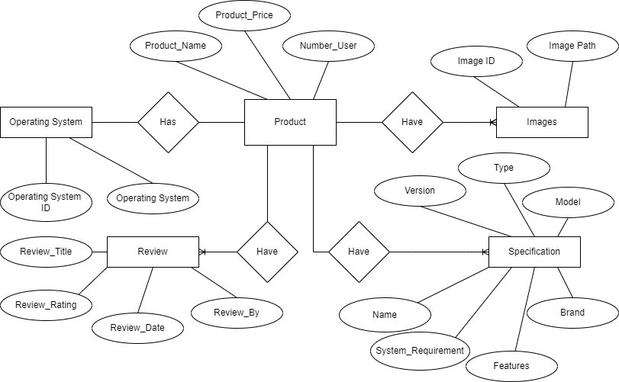

Fig. 3.1 Entity Relationship Diagram

**3.2 Data Flow Diagram**

**DFD Context Level**

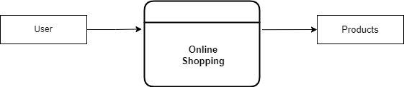

Fig. 3.2 Context Level Data Flow Diagram

**DFD First Level**

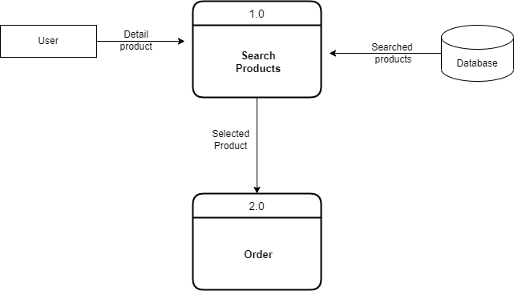

Fig. 3.3 1-Level Data Flow Diagram

DFD Second Level

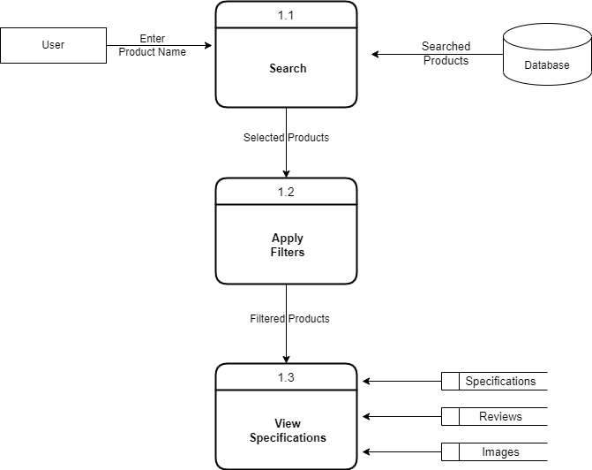

Fig. 3.4 2-Level Data Flow Diagram

**DFD Second Level**

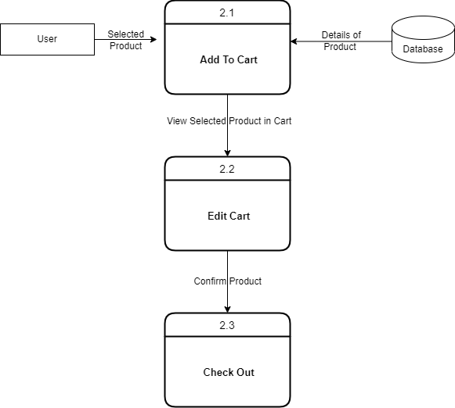

Fig. 3.5 2-Level Data Flow Diagram

### 3.3 Use Case Diagram

Use Case Diagram

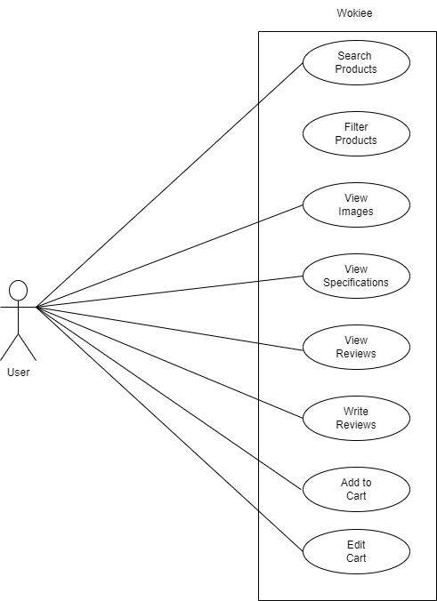

Fig. 3.6 Use Case Diagram

1. **Implementation**

**4.1 User Interface**

Home page of the website:

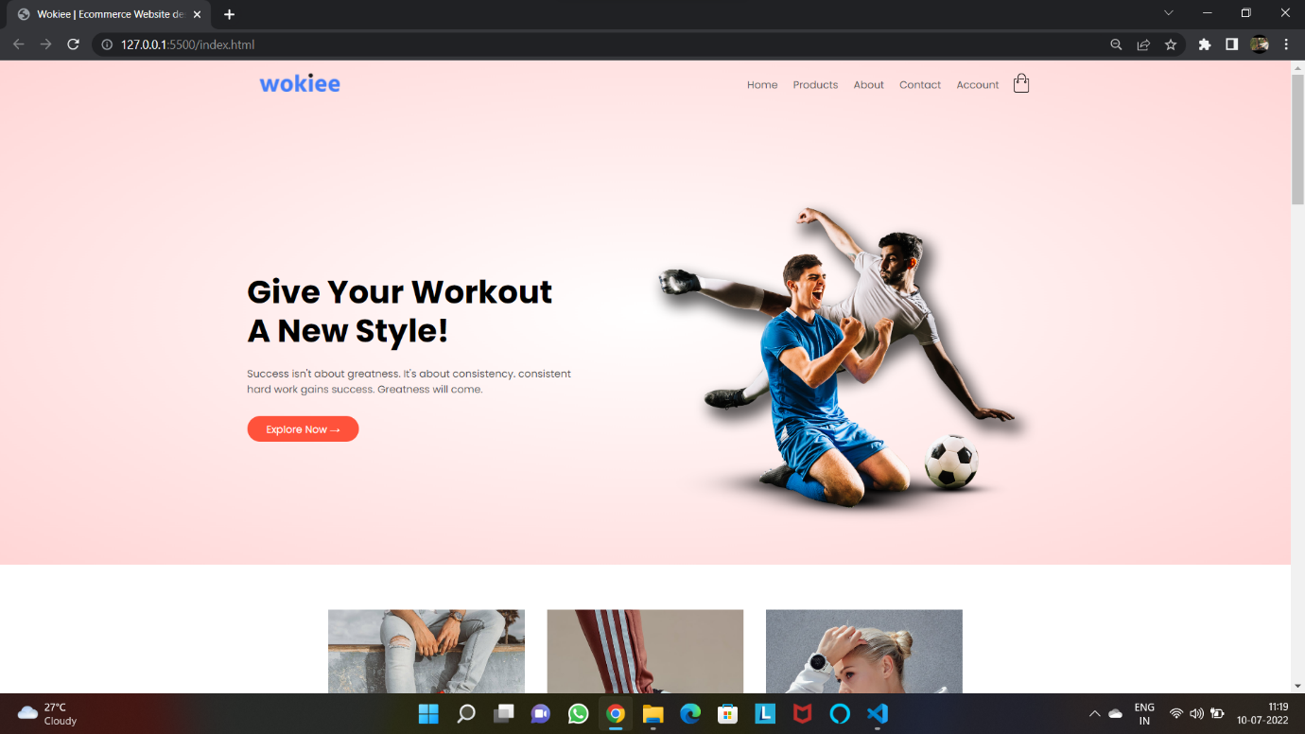

Fig. 4.1 Home Page Header

This is the home page of the project. It is looks interactive. Here click on the logo you can return in the home page again. Also, you can click on home button you can return in the home page.

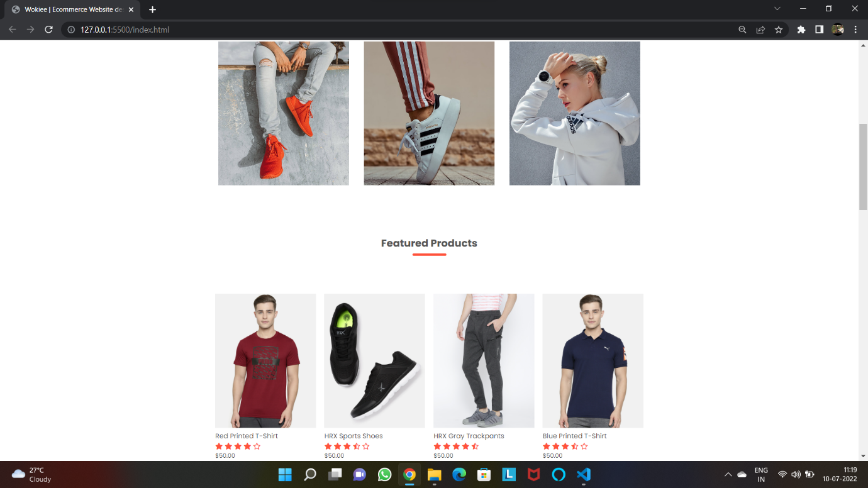

Fig. 4.2 Home Page

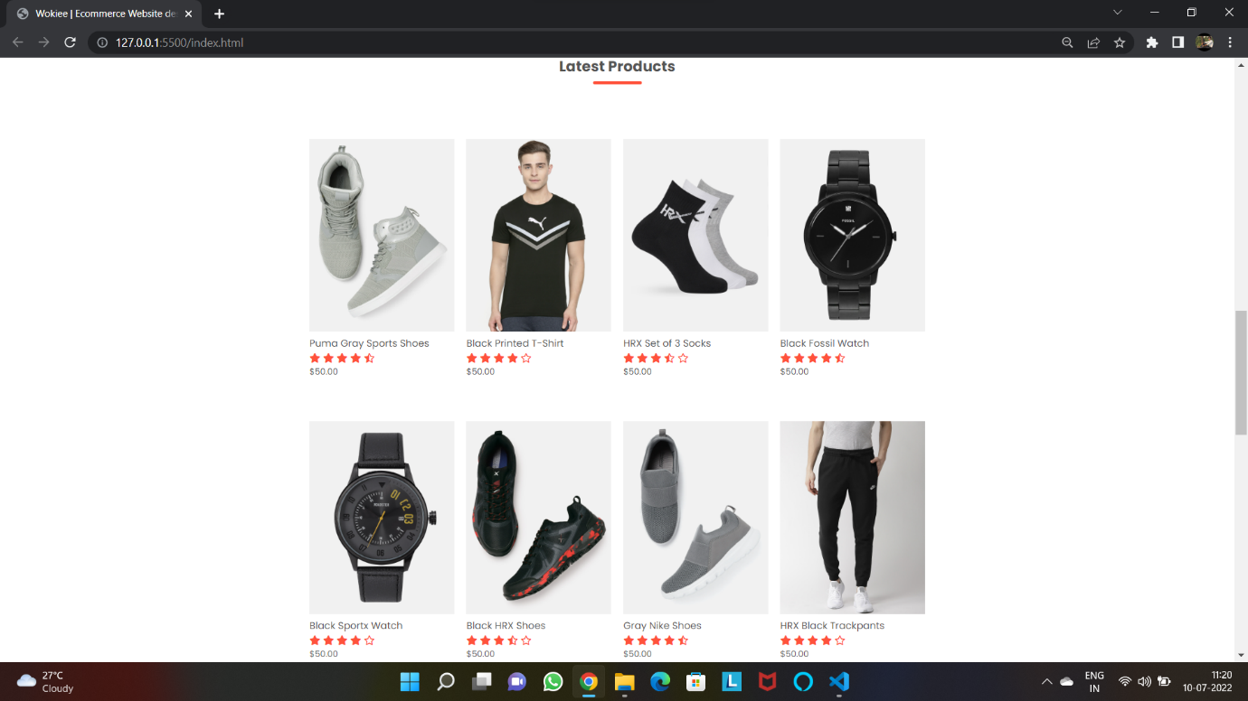

Fig. 4.3 Home Page

In this here are the list of latest products and featured products. Also, here the rating of the products. You can also see the hover effects on the product photos.

Exclusive Product of Home Page:

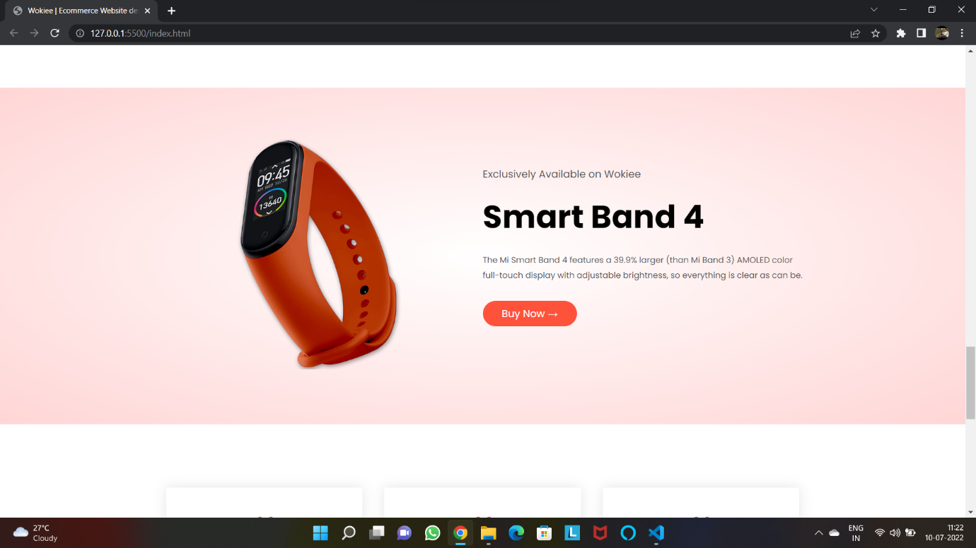

Fig. 4.4 Home Page Exclusive Product

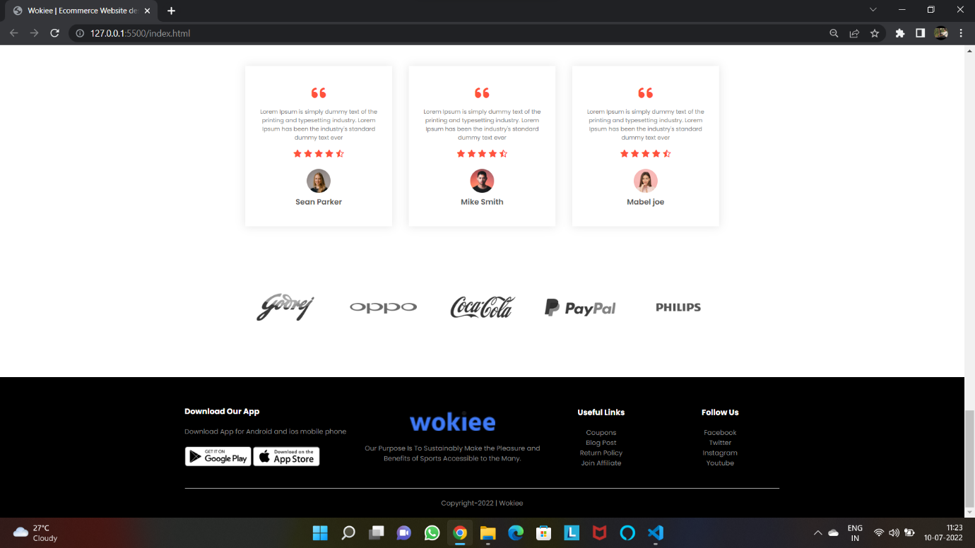

Fig. 4.5 Home Page Footer

Here is the exclusive product available on the web site is showed. Also, here are the reviews of the customers. In the last this is the footer of the home page.

All Products Page:

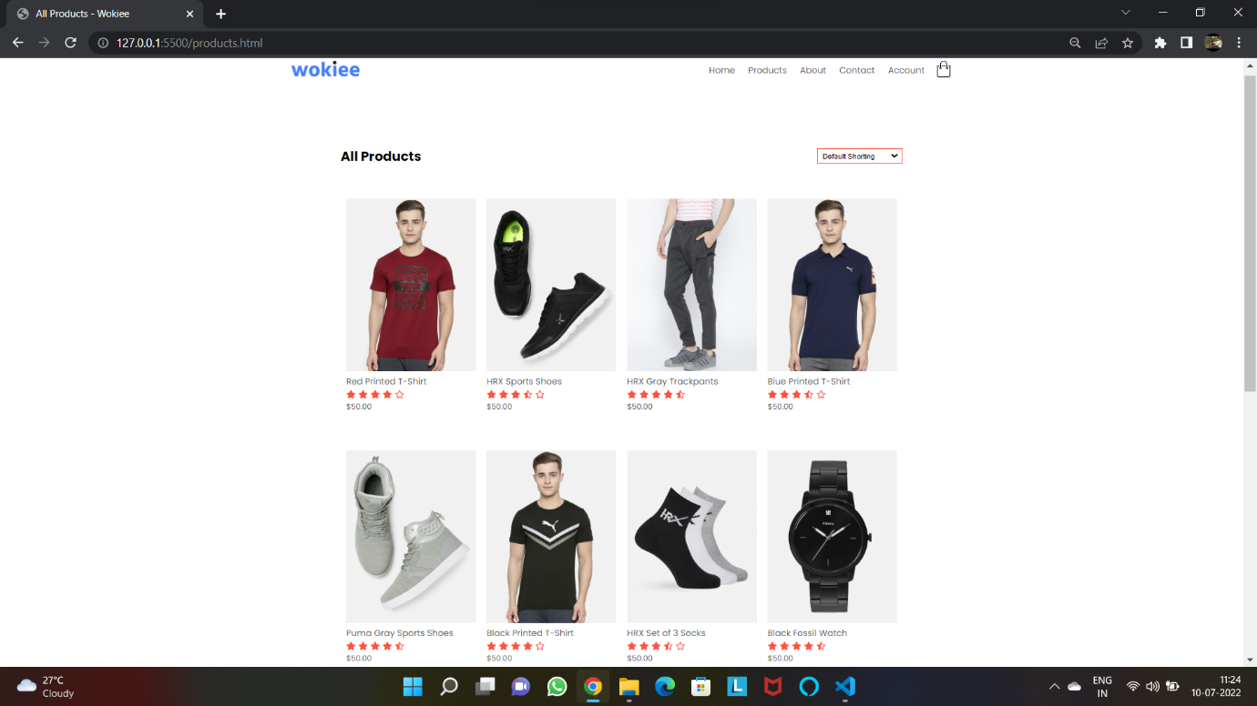

Fig. 4.6 Products Page

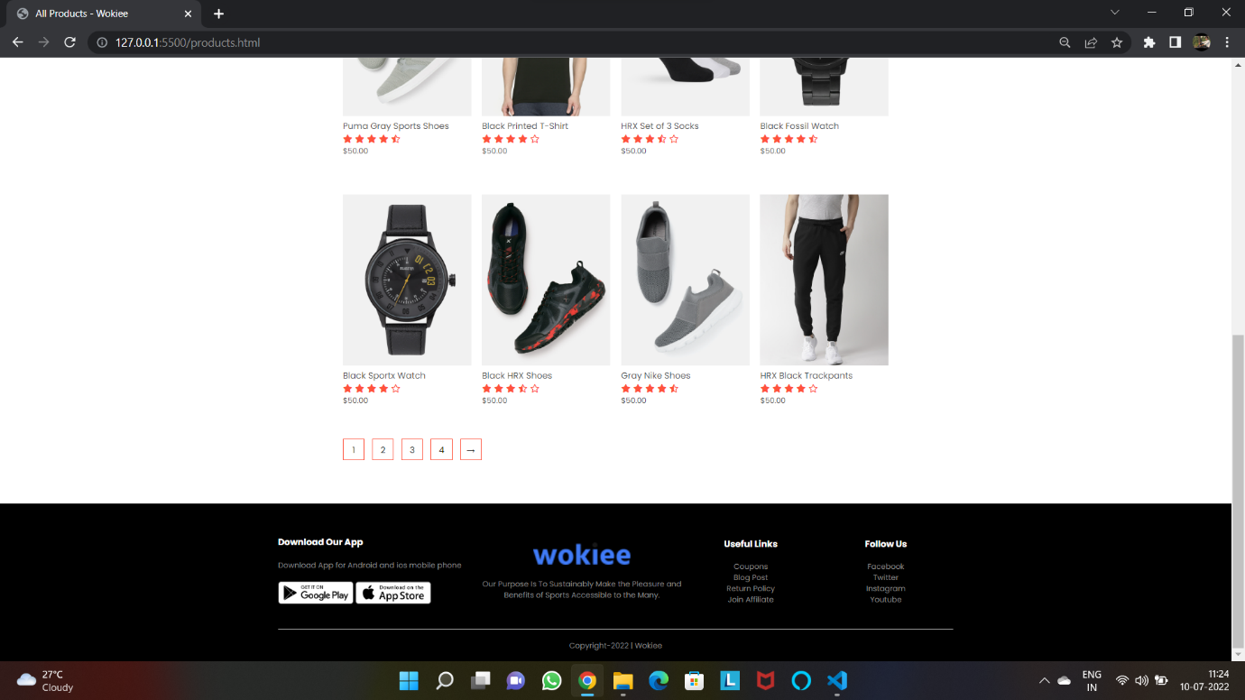

Fig. 4.7 Products Page

By click on the products button you can see the whole products page. By taking cursor on the product, you can also see the hover effect. Also, you can see the drop-down menu in the top right corner, you can sort the product by sorting.

Product Details Page:

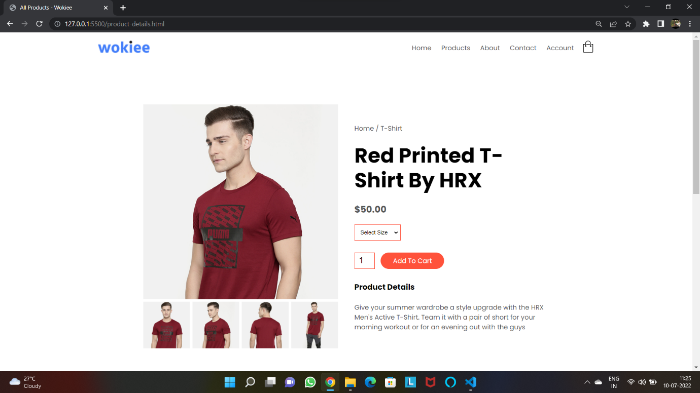

Fig. 4.8 Product Details Page

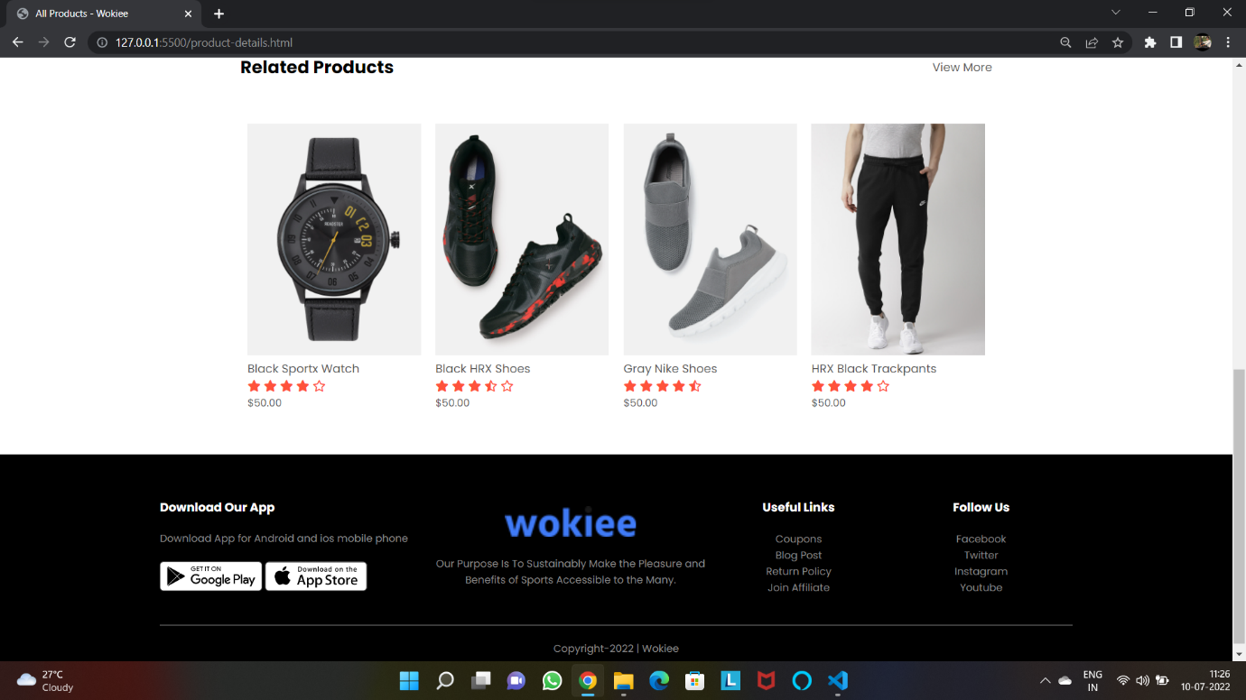

Fig. 4.9 Product Details Page

By clicking on the product, you can see the product details page. You can see the product’s different images by clicking on the small images. You can also select the size of the given product.

Account Page:

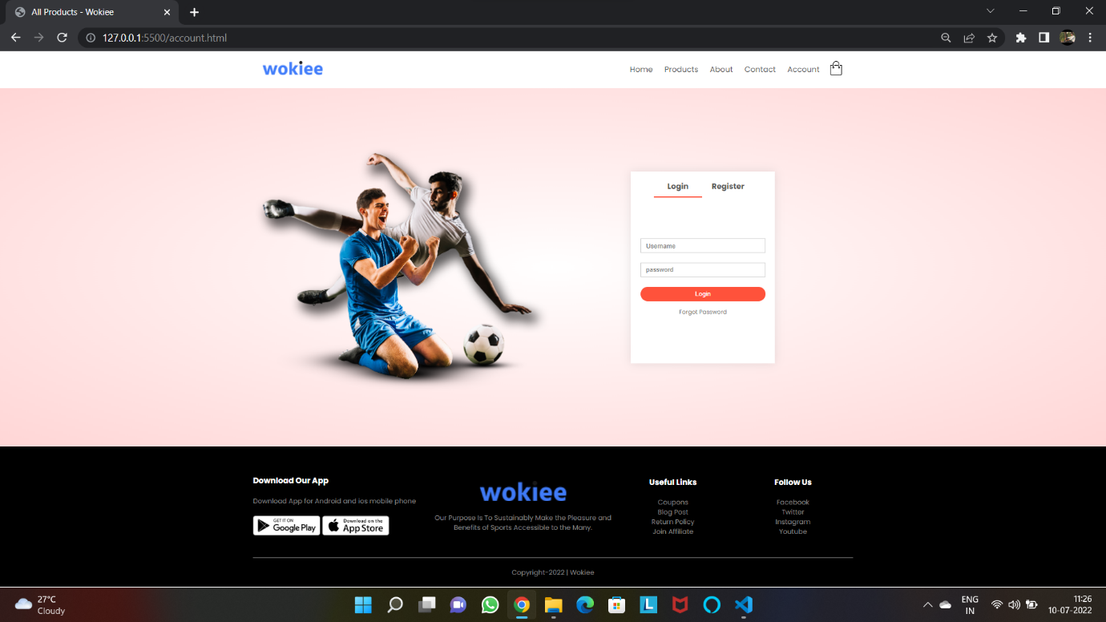

Fig. 4.10 Account Page

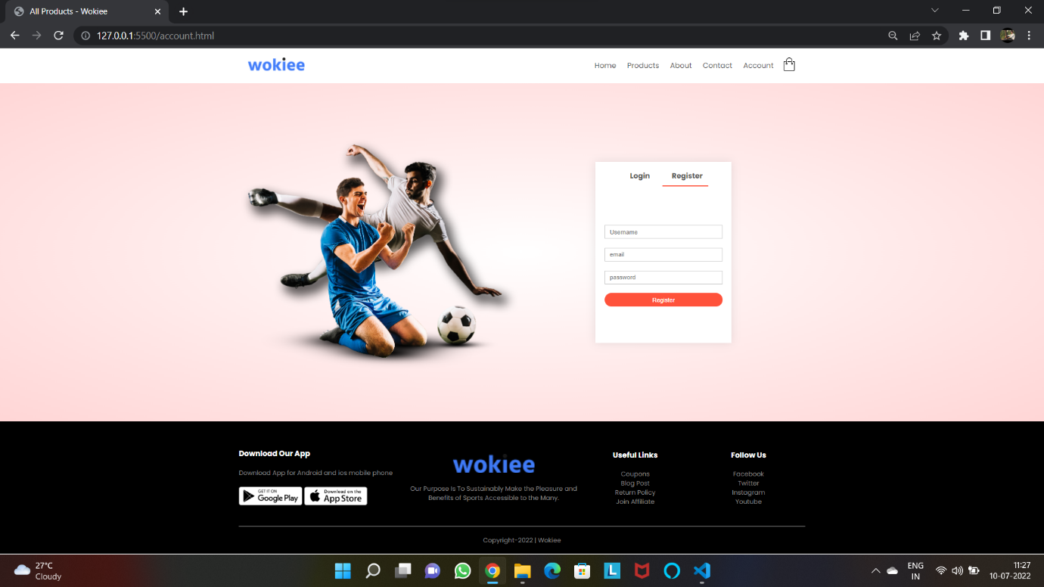

Fig. 4.11 Account Page

By clicking on the account button, you can see the account page. You can also see the effect of the register and log by clicking on them. If you are new user, you can register your account and if you are old user, you can login directly.

Cart Page:

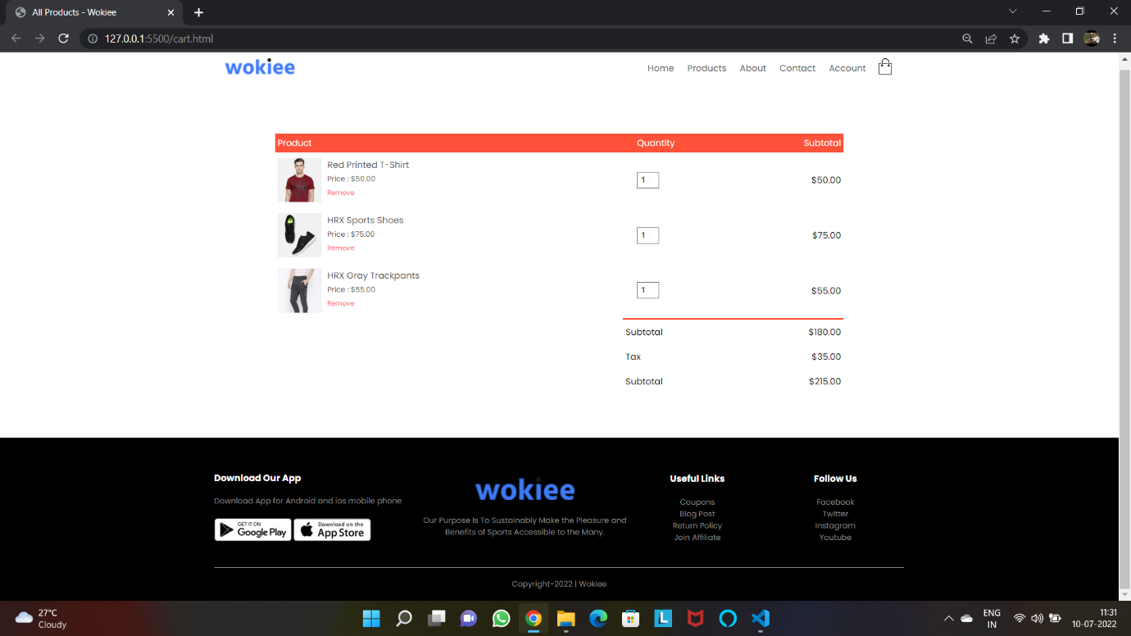

Fig. 4.12 Cart Page

By clicking on the cart icon, you can see the cart page. You can see all the selected products in this cart page and you also can check out the all your selected products.

1. **Conclusions**

The Wokiee is designed to provide a website that would make searching, viewing and selection of a product easier. The search engine provides an easy and convenient way to search for products where a user can Search for a product interactively and the search engine would refine the products available based on the user's input. The user can then view the complete specification of each product. They can also view the product reviews and also write their own reviews. Use of Ajax components would make the website interactive and prevents annoying post backs. Its drag and drop feature would make it easy to use.

### Limitations

This website does not have a built-in check out process. An external checkout package has to be integrated in to this website. Also, users cannot save the shopping carts so that they can access later i.e., they cannot create wish lists which they can access later. This website does not have features by which user can set price ranges for products and receive alerts once the price reaches the particular range.

### Scope for Future Work

The following things can be done in future.

* + - The current system can be extended to allow the users to create accounts and save products in to wish list.
    - The users could subscribe for price alerts which would enable them to receive messages when price for products fall below a particular level.
    - The current system is confined only to the shopping cart process. It can be extended to have an easy to use check out process.
    - Users can have multiple shipping and billing information saved. During checkout they can use the drag and drop feature to select shipping and billing information.

**REFERENCES**

• Wikipedia for various diagrams

https://www.wikipedia.org/

• Font Awesome website for symbols

https://kit.fontawesome.com/

• Draw website for drawing all diagrams

https://app.diagrams.net/

• Tutorials for easy implementation

https://www.youtube.com/c/EasyTutorialsVideo